Graph plotting results for the Regularization:

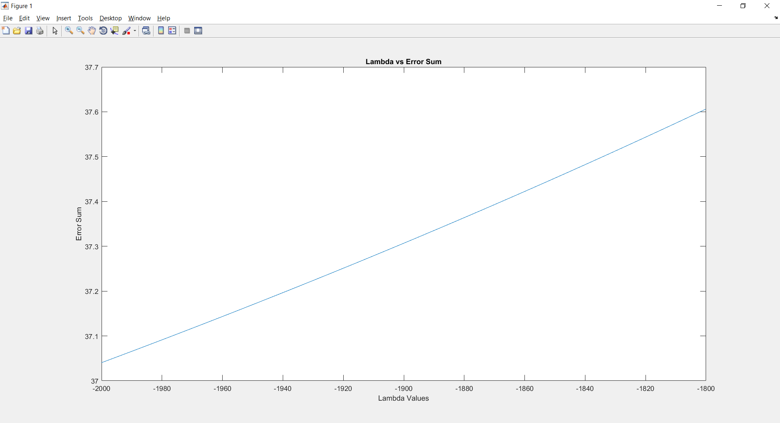

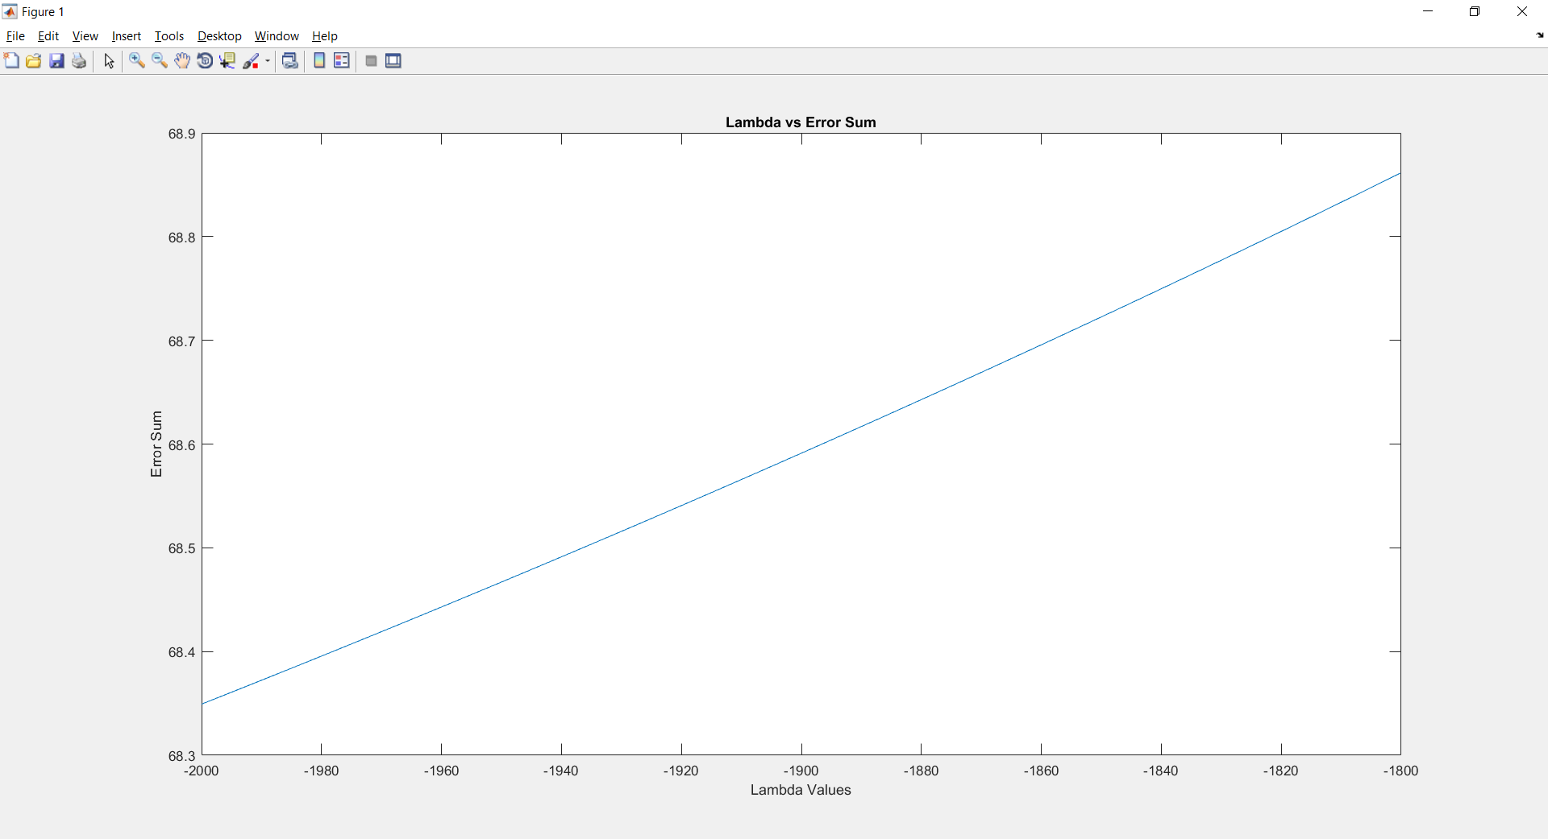

Graph plotting results for K-Fold Cross Validation:

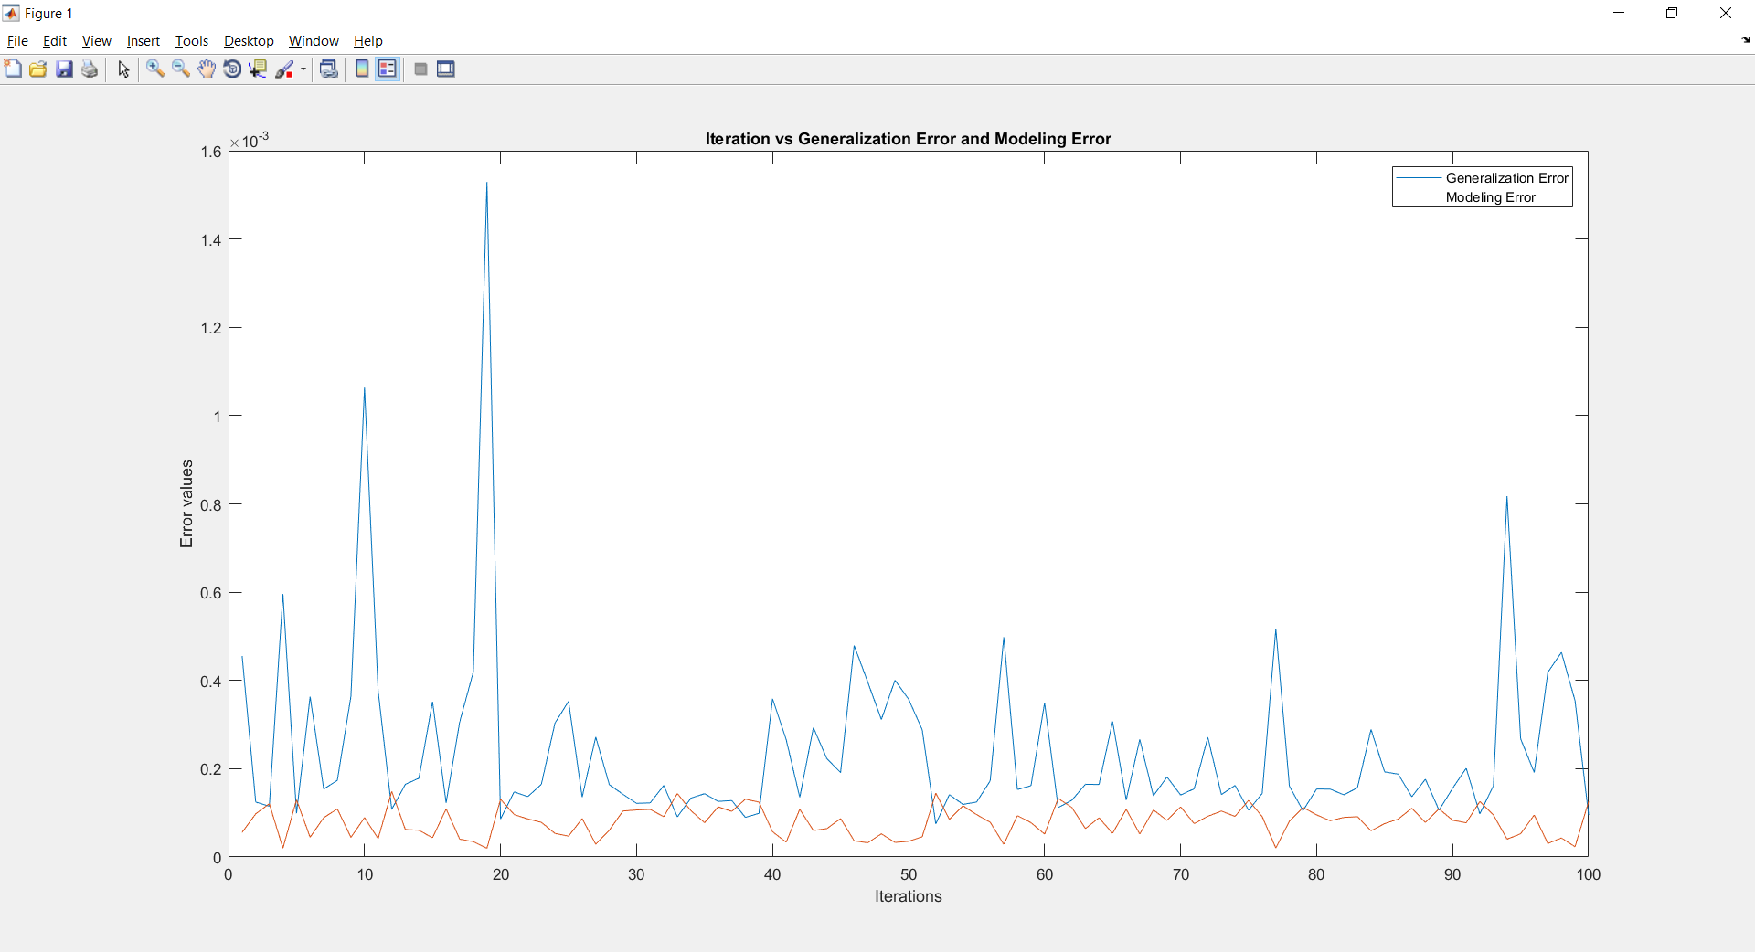

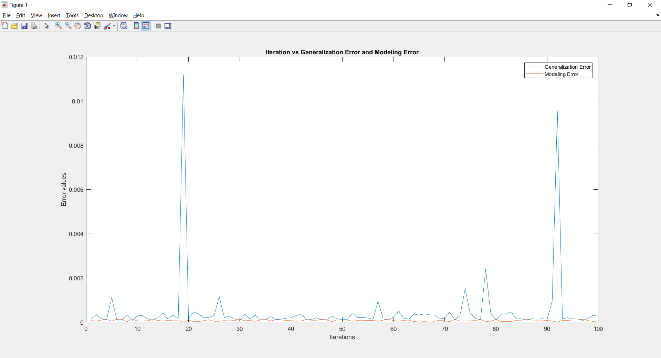

Graph plotting results for the Linear regression:

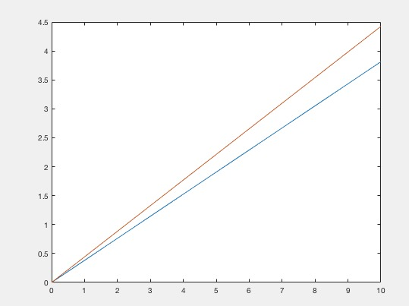

Graph plotting for Contours:

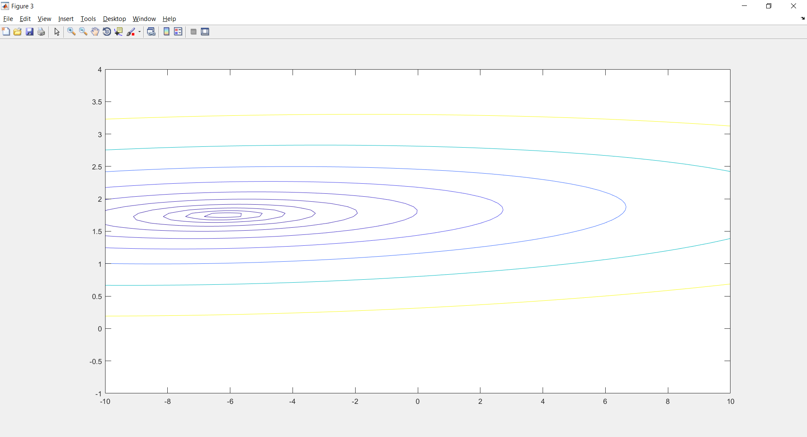

Reporting the values of Maximum, Mean, Minimum of Esum and also the Average Error values:

